DBA4301 – Business Analytics Solutions: Development and Deployment

Individual Assignment 1
Name: Sai Ashwin Kumar Chandramouli
ID No: A0329294U

Task A:
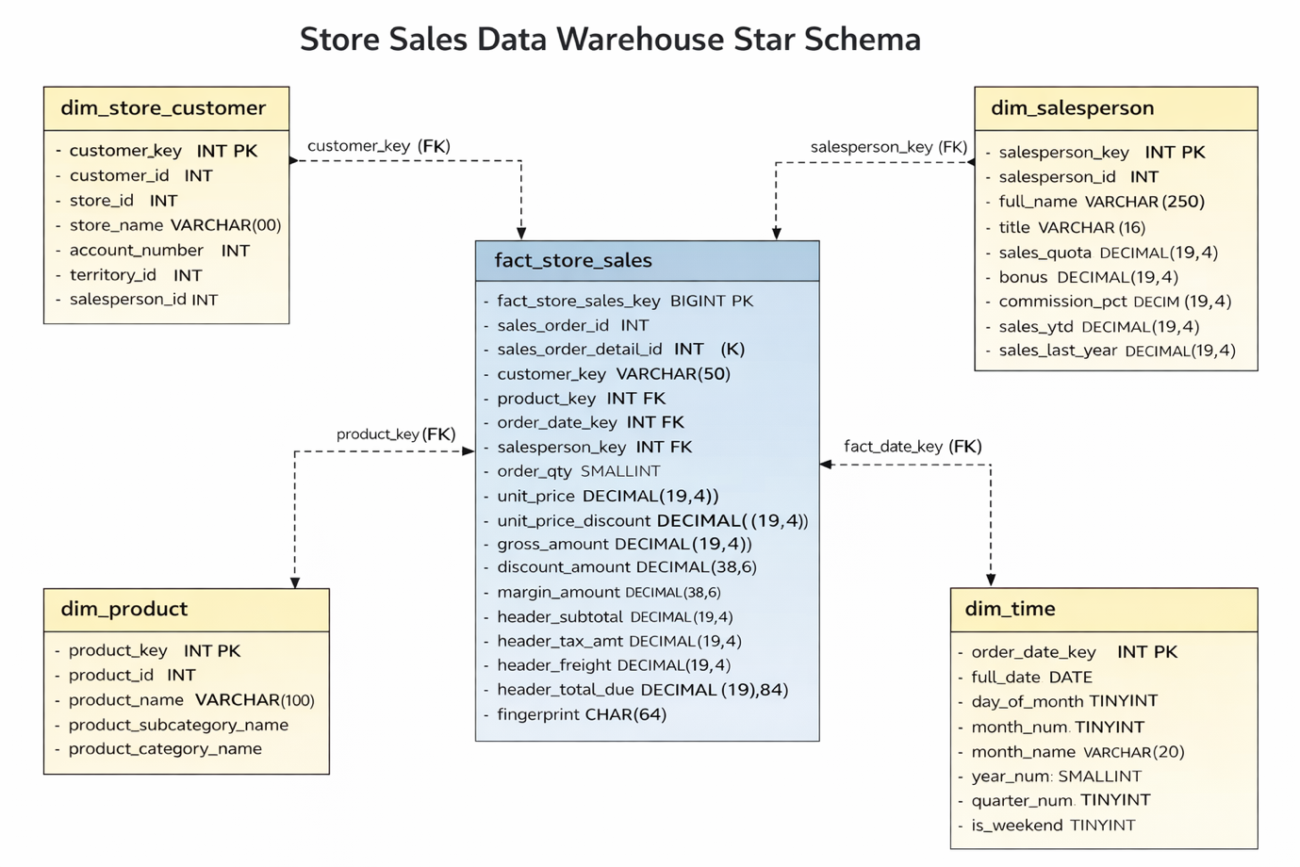
The above star schema is designed for store-customer sales analysis in the AdventureWorks data warehouse. For the dimension tables, we have the basic dimensions (store) customer, product, time and the additional dimension salesperson. dim_store_customer captures the store customer entity, including store name, account number, territory, and assigned salesperson. dim_product provides rich product attributes such as category, subcategory, model, size, cost, and list price, enabling product-level and profitability analysis. dim_time standardizes date-based reporting by providing day, month, quarter, year, week, and weekend indicators. dim_salesperson is the additional dimension introduced beyond customer, product, and time, and it supports analysis of sales performance by representative.
The central table is fact_store_sales, at the grain of one sales order line per store customer transaction. It stores the measurable sales values such as quantity, unit price, gross amount, discount amount, margin amount, net amount, and header-level charges like tax and freight. The fact table links to four dimensions through surrogate keys, which supports efficient analytical queries and keeps the schema stable even if source-system business keys change.
For the sales fact table, three additional row-level transformations were introduced to make the data more useful for store-customer analysis. These transformations were chosen such that they do not rely on direct aggregations like sum, mean, or median, since those can already be performed later through the star schema.
- The first transformation is gross amount, calculated as order_qty × unit_price. This represents the original value of each sales order line before any discount is applied. It is useful for understanding the base sales value of store purchases and for comparing pre-discount and post-discount performance.
- The second transformation is discount amount, calculated as order_qty × unit_price × unit_price_discount. This captures the monetary value of the discount applied to each order line. For store customers, who often receive negotiated or volume-based discounts, this measure helps analyse the effect of discounting on sales transactions.

- The third transformation is margin amount, calculated as net_amount − (order_qty × standard_cost). This provides an estimated profit contribution for each sales order line after accounting for product cost. It is especially relevant for store customers because it allows profitability to be analysed at transaction level rather than only sales value.
The raw_store_sales table is also retained alongside the transformed star schema, which is good design practice because it preserves the original extracted transactional data for traceability, auditing, and reprocessing. Overall, this schema is well suited for descriptive analytics on store sales, especially for studying customer buying patterns, product performance, time trends, discounts, and salesperson contribution.
The file assignment1_etl.ipynb contains a one-time test of the ETL flow. It extracts data from the source AdventureWorks database using the MySQL connector, applies star schema transformations specific to store-customer-level data based on the schema diagram above, and implements the required row-level transformations for additional analysis without discarding the raw fact data. The transformed data is then loaded into a destination MySQL database, datawarehouse, which simulates a data warehouse. This test flow ingests data for only the first month.
After the flow was tested successfully, it was automated and orchestrated using an Airflow DAG in the file assignment1_etl_airflow.py. The DAG is designed to load dimension and fact data into the warehouse according to the same tested notebook flow, one month at a time at regular intervals (5 minutes).

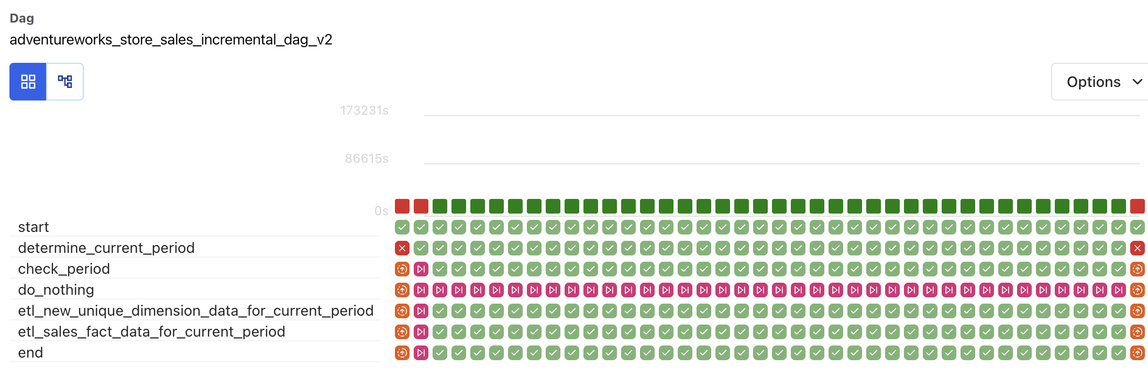
do_nothing is skipped and shown in maroon for the runs where the period value is between 1 and 37 because the branch condition sends the DAG to the ETL path instead. In Airflow, tasks on the non-selected branch are automatically marked as skipped, which is why do_nothing appears maroon in those runs.
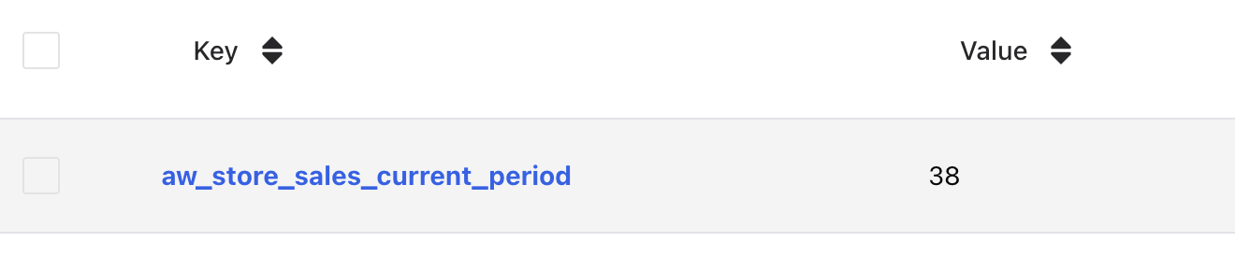
To manage the monthly ingestion systematically, it maintains a variable that increments each time a month’s data is successfully loaded into the warehouse. Since the source data is available for only 37 months, the ETL pipeline does not trigger once the variable value exceeds 37.

Task B:
The file assignment1_visualisation.ipynb implements three additional operations using only the data already loaded into the datawarehouse, beyond those shown in the sample code.
The first operation is data profiling. The notebook performs basic quality checks on the warehouse data, such as duplicate fact rows, missing dimension attributes, invalid discount values, and non-positive quantity or price values. This was done to confirm that the loaded store-customer sales data is suitable for analysis.
The second operation is data cleansing for analytical use. A cleaned analytical dataset was created from the warehouse data by removing duplicate order-line records and filtering out rows with invalid business values. The warehouse tables themselves were not modified, so the raw loaded data was preserved.
The third operation is descriptive analytics for store customers. Using the cleaned warehouse data, several visualisations were created to analyse store-customer performance from different perspectives.
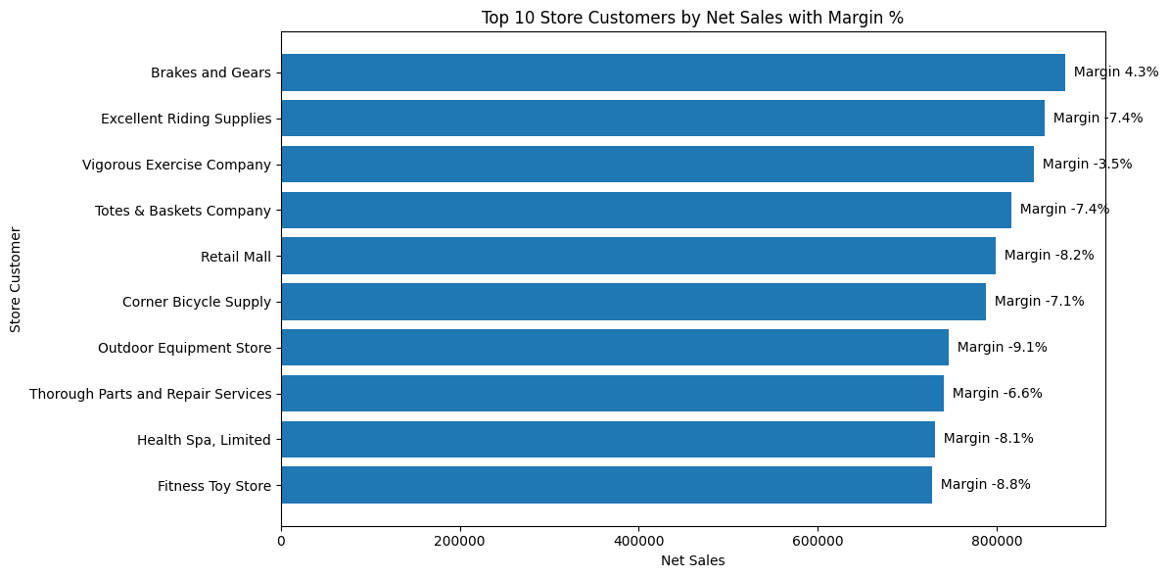
The first visualisation, Top 10 Store Customers by Net Sales with Margin %, shows the highest-revenue store customers while also indicating their margin percentage. This helps distinguish customers who generate high sales from those who are actually profitable. For example, although some stores contribute large net sales, many of them have negative margins, which highlights potentially unprofitable customer relationships.
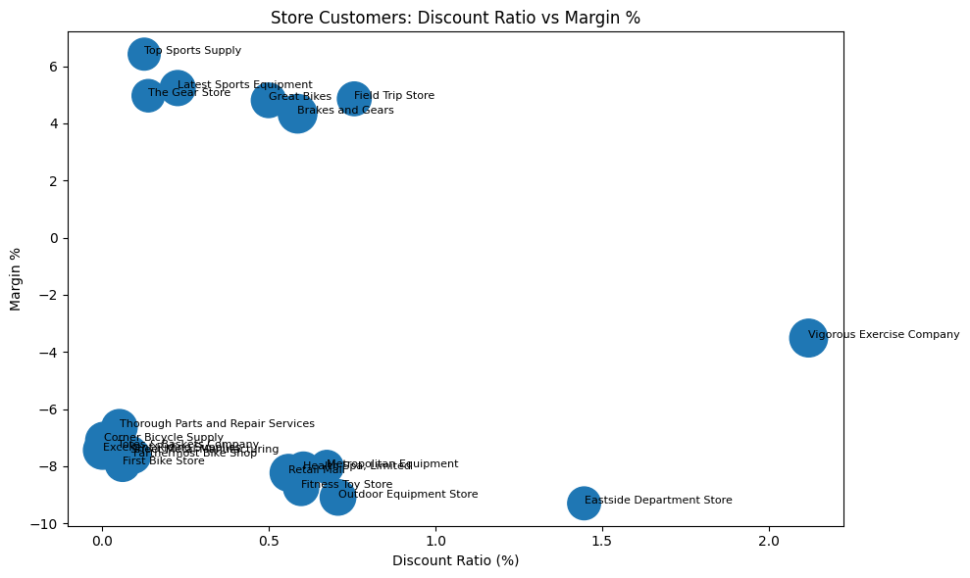
The second visualisation, Discount Ratio vs Margin % by Store Customer, examines whether store profitability is being affected by discounting. Each point represents a store customer, with the x-axis showing discount ratio and the y-axis showing margin percentage. This visual helps identify customers who receive relatively higher discounts but still yield weak or negative margins, making it useful for pricing and negotiation analysis.
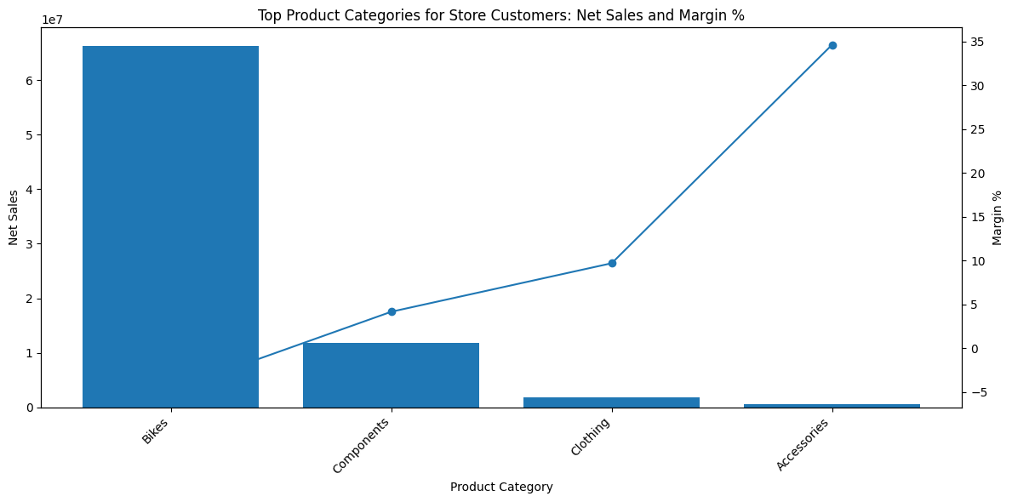
The third visualisation, Top Product Categories for Store Customers: Net Sales and Margin %, compares product categories by both sales volume and profitability. The bars show net sales while the line shows margin percentage. This helps identify categories that drive revenue versus categories that drive profit. In the results, Bikes contribute the highest net sales, while Accessories show the strongest margin percentage despite much lower sales volume.
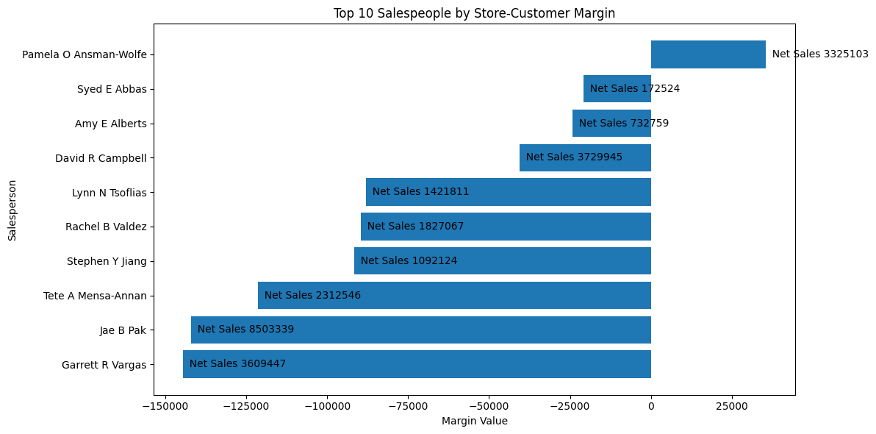
The fourth visualisation, Top 10 Salespeople by Store-Customer Margin, evaluates salesperson performance based on the margin generated from store-customer sales. This goes beyond sales volume by focusing on profitability contribution. The chart helps identify which salespeople are associated with stronger or weaker profit performance across store accounts.
Together, these profiling, cleansing, and descriptive analytics operations show how the warehouse can be used not only for storing transformed data, but also for validating data quality and generating meaningful business insights for store customers.

Task C:
The file assignment1_watermark.py implements a new Airflow DAG to perform data watermarking on the fact_store_sales table in the datawarehouse. The DAG follows the required SHA256-based watermarking approach using Python’s hashlib module. It first checks whether the fingerprint column exists in the existing sales fact table and appends it if necessary, without creating a new table. It then computes a SHA256 fingerprint for each fact record based on a fixed set of business and measure columns and updates rows whose fingerprint is missing. Since the fingerprint is stored as an additional nullable column in the same fact table, the existing ETL pipeline is not disrupted.
The file assignment1_watermark_verify.py implements a second Airflow DAG to verify the integrity of the fingerprint field periodically. This DAG is scheduled to run once daily and recomputes the SHA256 fingerprint for every row in fact_store_sales, comparing the recomputed value with the stored fingerprint. Any row with a missing or mismatched fingerprint is treated as unverified and written to a log file stored in the configured log directory. The log filename is generated using the start time of the DAG run in the required YYYYMMDDHHMM.log format.
To test the verification process, certain records in the sales fact table were manually modified after watermarking had already been applied.
For example, the following updates were done through MySQL in terminal:
UPDATE fact_store_sales
SET net_amount = net_amount + 10
WHERE fact_store_sales_key = 1;
-------------------------------------------------
UPDATE fact_store_sales
SET order_qty = order_qty + 1
WHERE fact_store_sales_key = 2;
When the verification DAG was run, these modified records were correctly identified as fingerprint mismatches and written to the log file.
Log file: (202603221838.log)
FINGERPRINT_MISMATCH | fact_store_sales_key=1 | sales_order_id=43659 | sales_order_detail_id=1 | stored=3d670963144b992b1882bc9eceb9c603c90ce6c15d8d211c5705105b0b07e548 | expected=89afd003eadf44bcfa1ad1f82c88631e8fd2f9bcf62f7775a29be29d1095ee8e
FINGERPRINT_MISMATCH | fact_store_sales_key=2 | sales_order_id=43659 | sales_order_detail_id=2 | stored=1901042d28d4d7b4490bbc137f4ca1f253c7867921cf0f63ef36c8789b4e3f94 | expected=2616d63d18d8cf528549b671c2ea38275044486158ebe6a1e640a3155f94a6bb
The generated log confirms that the integrity-checking mechanism is functioning as intended and is able to detect unintended changes made to the warehouse fact data.
AI Declaration: I used ChatGPT 5.4 and Codex Copilot to assist with brainstorming, code drafting, debugging support, visualisation ideas, and improving the clarity and presentation of written sections in this assignment. All outputs were reviewed, adapted, and validated by me, and I take full responsibility for the final submission.

